CSA0502 – QUERY PROCESSING FOR DATASCIENCE
Lab Programs

7. Pivot Table (Maximum & Minimum Sale Value)
Aim
To create a pivot table and find the maximum and minimum sale value.
Code
import pandas as pd

data={
"Item":["Pen","Pen","Book","Book","Pencil"],
"Sale":[100,120,250,200,80]
}

df=pd.DataFrame(data)

pivot=df.pivot_table(values="Sale",index="Item",aggfunc=["max","min"])

print(pivot)
OUTPUT:
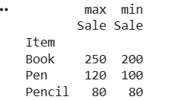
Result
Maximum and minimum sale values displayed.

8. Pivot Table (Item-wise Unit Sold)
Aim
To create a pivot table and find item-wise units sold.
Code
import pandas as pd

data={
"Item":["Pen","Pen","Book","Book","Pencil"],
"Units":[10,15,20,25,18]
}

df=pd.DataFrame(data)

pivot=df.pivot_table(values="Units",index="Item",aggfunc="sum")

print(pivot)
OUTPUT:
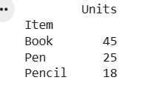
Result
Item-wise units sold displayed.

